Architecture Documentation
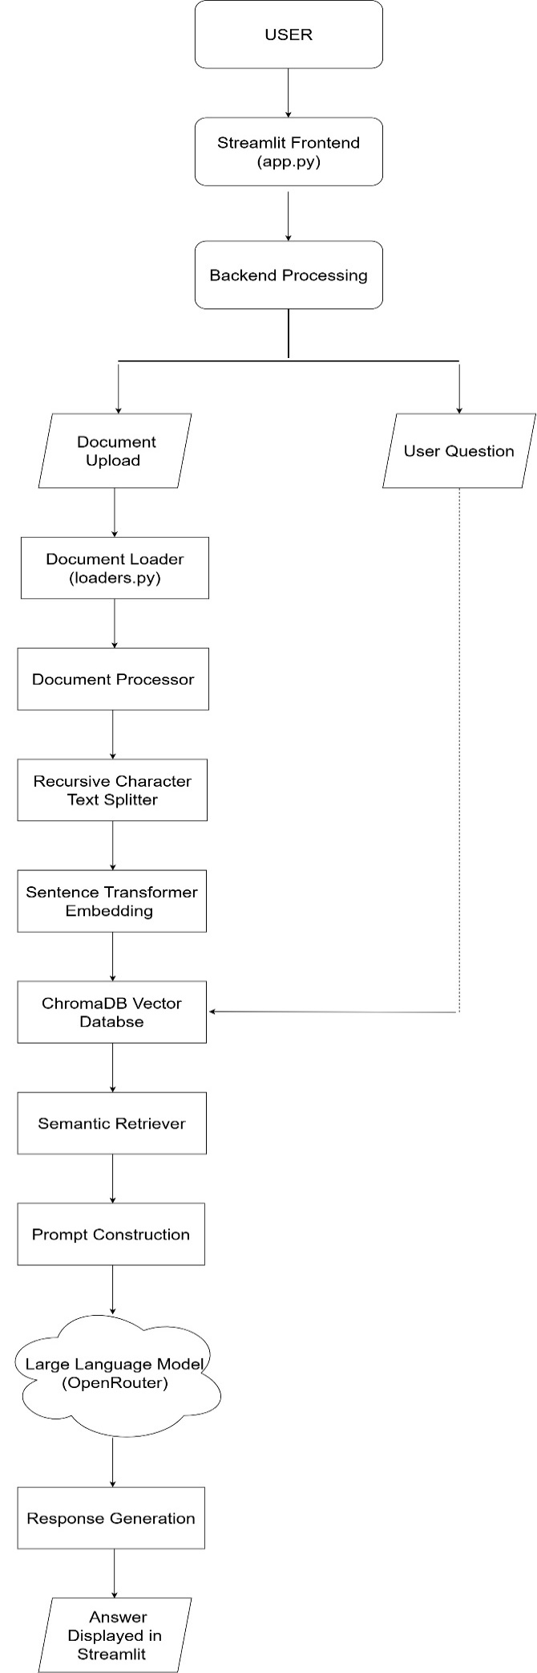
Figure 1: Enterprise Document Intelligence Platform Architecture

Component Explanation
1. User
The user interacts with the Enterprise Document Intelligence Platform through the Streamlit web interface. The user uploads enterprise documents and asks questions related to those documents.
Role
- Upload documents
- Ask questions
- Receive AI-generated answers
2. Frontend (Streamlit)
The frontend was developed using Streamlit. It provides an easy-to-use interface where users upload documents and interact with the chatbot.
The frontend also displays:
- Uploaded document information
- Number of pages
- Character count
- Chunk count
- Chat interface
- AI responses
- Project File
- app.py

3. Backend
The backend coordinates all processing steps after receiving user input. It controls document processing, embedding generation, retrieval, and communication with the language model.
The backend manages the overall RAG workflow.
Responsibilities
- Receive uploaded files
- Process documents
- Execute semantic retrieval
- Send prompts to the LLM
4. Document Processing
After a document is uploaded, it is processed using LangChain document loaders. The text is extracted from supported document formats before further processing.
During the project, uploaded PDF and Word documents were converted into plain text for chunking.
Responsibilities
- Read uploaded files
- Extract text
- Prepare documents for chunking

5. Chunking
Large documents cannot be processed efficiently as a single block of text. Therefore, the extracted text is divided into smaller chunks using RecursiveCharacterTextSplitter.
Project configuration:
- Chunk Size: 800
- Chunk Overlap: 150
Chunk overlap preserves context between neighboring chunks and improves retrieval quality.
6. Embedding Generation
Each document chunk is converted into a numerical vector called an embedding.
The project used:
Sentence Transformers
all-MiniLM-L6-v2
Embeddings allow the application to search documents based on meaning instead of exact keywords.
7. Vector Database
The generated embeddings are stored inside ChromaDB.
Instead of storing plain text only, ChromaDB stores vector representations that enable semantic similarity search.
The vector database makes document retrieval fast and accurate.
8. Retriever
When the user asks a question, the question is converted into an embedding.
The retriever compares this embedding with all stored document embeddings and selects the most relevant chunks.
This ensures that only useful information is passed to the language model.
9. Large Language Model (LLM)
The retrieved document chunks and the user's question are combined into a prompt and sent to the language model.
In this project, the application communicates with the model through OpenRouter.
The LLM generates an answer using both:
- Retrieved document context
- User question
10. Response
The generated answer is returned to the Streamlit interface and displayed to the user.
Because the response is based on retrieved document content, it is more accurate and significantly reduces hallucinations compared to using a standalone language model.
Complete Workflow
- User uploads a document.
- The backend extracts the document text.
- The document is split into chunks.
- Each chunk is converted into embeddings.
- Embeddings are stored in ChromaDB.
- The user asks a question.
- The question is converted into an embedding.
- ChromaDB retrieves the most relevant document chunks.
- Retrieved chunks and the question are sent to the LLM through OpenRouter.
- The generated answer is displayed in the Streamlit interface.

